**User Manual for Russian Roulette game**

For teacher:  
**1st** of all a line of code has to be modified in the app.config of the ServiceLibrary. In the <connectionStrings>

Find the piece of code which specifies the path

C:\Users\Shadow\Desktop\Screen 2014.6.12 14-40-56.9.jpg

And change it to the path where the project is located on your PC.

**2nd** It is preferable to run the client form the Bin🡪Debug folder of the project folder.

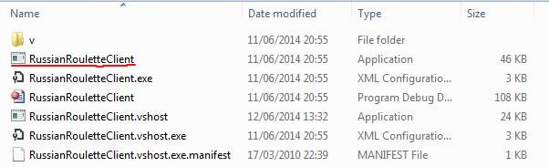

In General:

All users must have DirectX installed on their machines in order to be able to play the game.